ServiceNow Administrator Project Documentation
Functional Solution Design (FSD) Document
1. Introduction
- Project Title: Auto Ticket Classification using Flow Designer
- Team ID: SWTID-2026-7735
- Project Author: Deepak (ServiceNow Administrator / Flow Designer Specialist)
- Submission Date: 03 October 2026
- Project Track: ServiceNow Administrator Track – Practical Implementation Deliverable
2. Project Overview & Business Requirements
The school IT helpdesk receives multiple incident requests daily from students and teachers, such as Wi-Fi issues, projector failures, password problems, and slow computers. Currently, IT staff manually reviews each request and assigns a category, which is time-consuming and inefficient. This project automates ticket classification using ServiceNow Flow Designer by analyzing keywords in the incident's short description and description fields.
Business Requirements: (1) Automatically classify IT tickets based on description; (2) Assign Category and Subcategory without manual intervention; (3) Support dependent choice logic; (4) Send automated email notification to caller; (5) Standardize data storage; (6) Ensure easy no-code maintenance.
3. Update Set & Governance Configuration
Navigation: All menus -> System Update Sets -> Local Update Sets -> New. Name: 'Project Update Set', State: 'In progress', Application: 'Global'. Under Related links, click 'Make This My Current Set'.
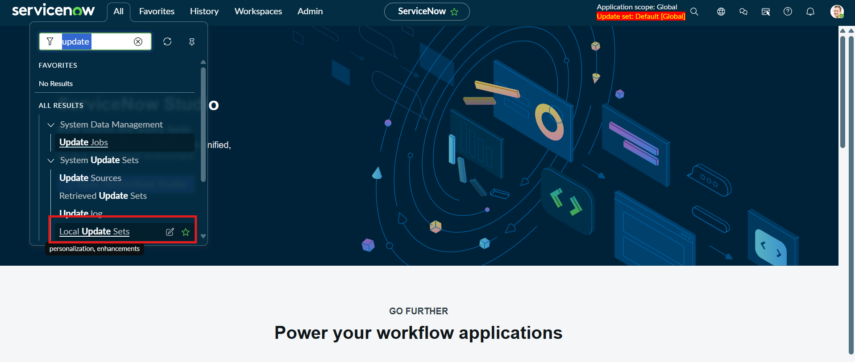
Figure 6.1: Navigating to System Update Sets -> Local Update Sets in All Menus
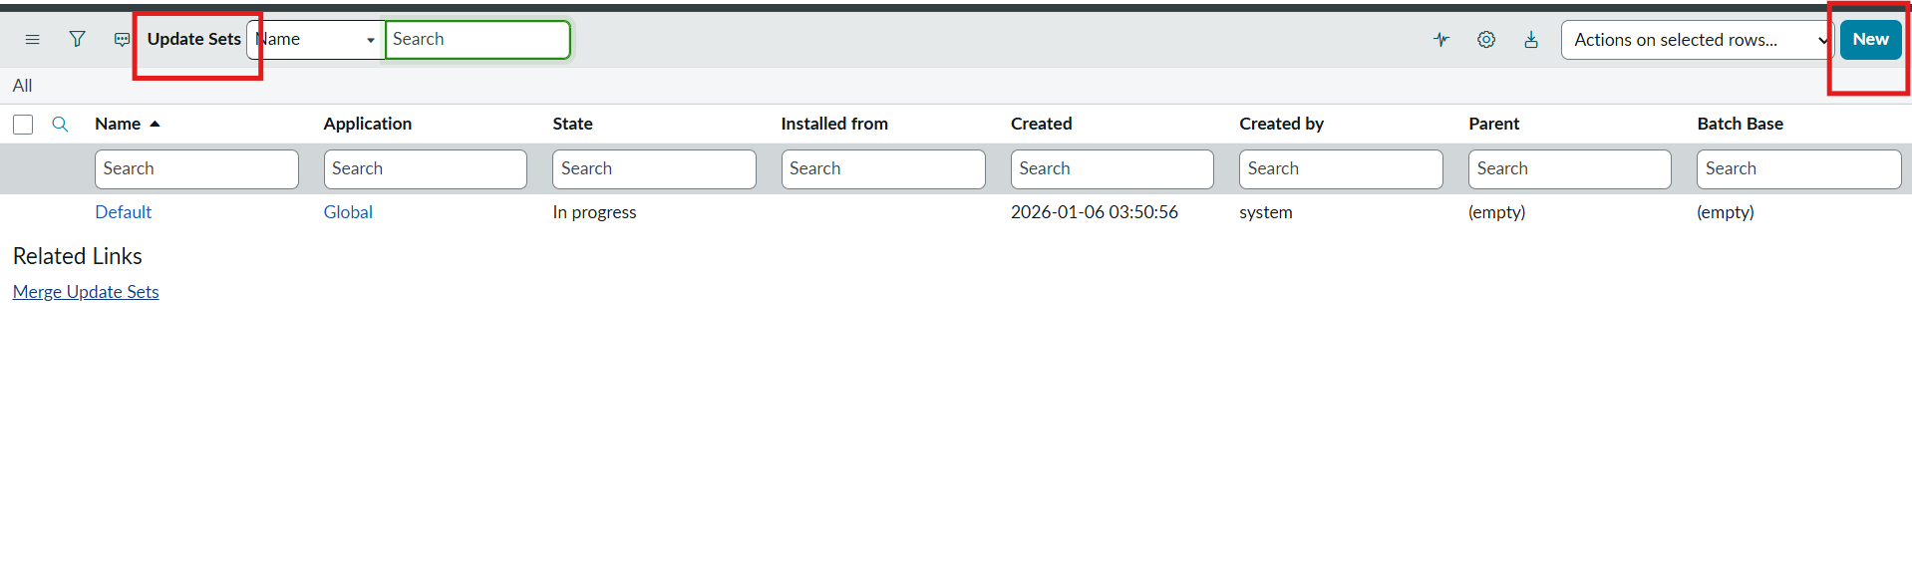
Figure 6.2: Creation of 'Project Update Set' with Global Scope and Make This My Current Set
4. Custom Table & Schema Design
Navigation: All menus -> System Definition -> Tables -> New. Label: 'Incident WorkFlow' (u_incident_workflow). Uncheck 'Create module'. In Controls section: Check 'Auto Number' = true. Prefix: 'INC', Number: '500', Number of digits: '5'.
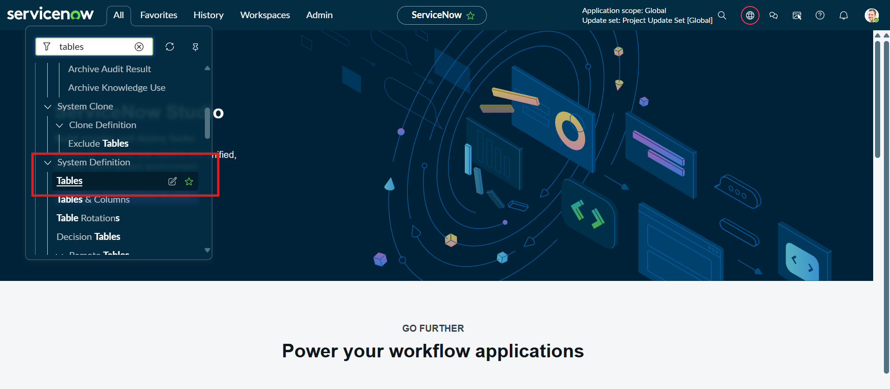
Figure 6.3: Navigating to System Definition -> Tables
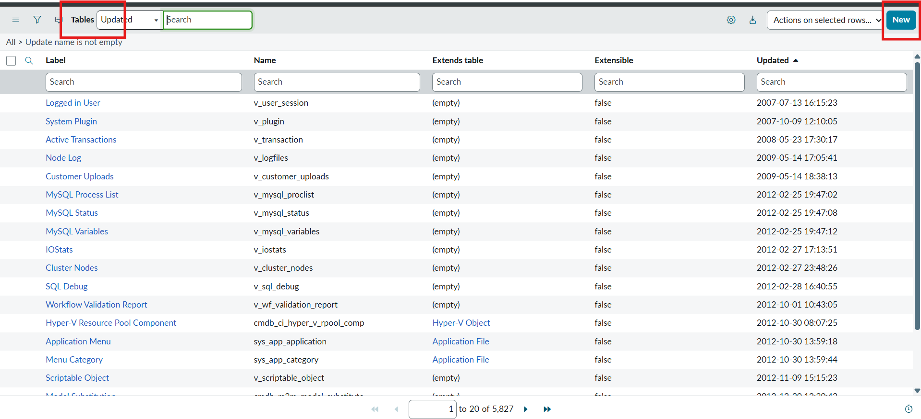
Figure 6.4: Tables List View and 'New' Table Action
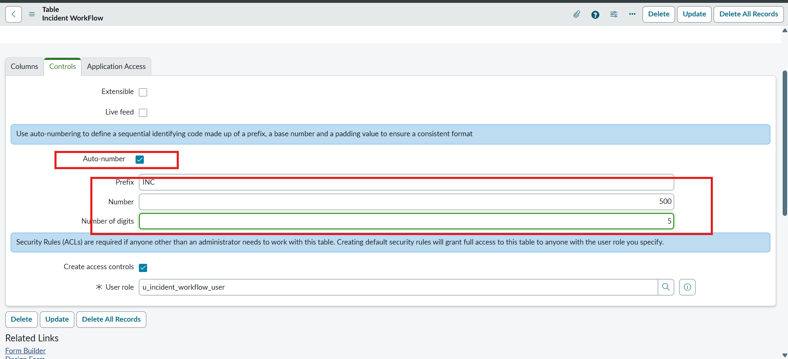
Figure 6.5: Table Properties Configuration and Controls Auto Numbering Setup (Prefix: INC)
5. Form Design & Field Creation
Navigation: Open table form -> Context Menu -> Configure -> Form Designer. Create fields: Number, Caller (sys_user), Category (Choice), Subcategory (Choice), Short Description (String), Description (String), State (Choice), Assigned group (sys_user_group), Assigned to (sys_user).
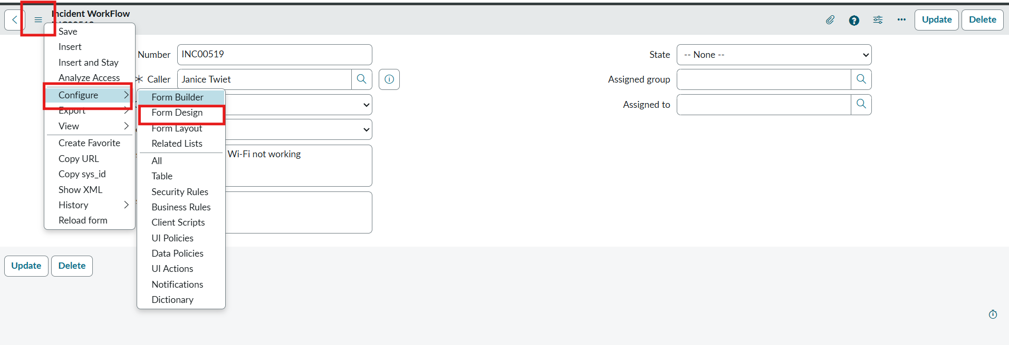
Figure 6.6: Form Context Menu -> Configure -> Form Designer
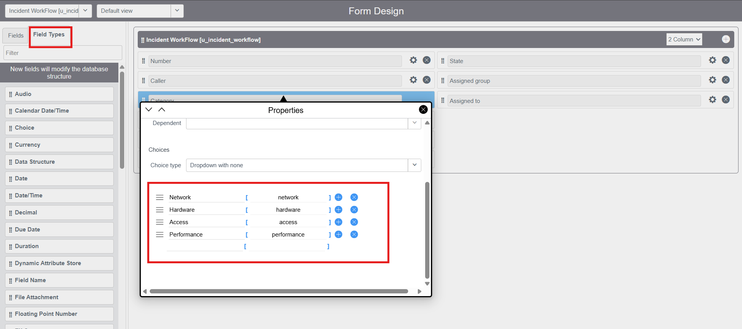
Figure 6.7: Form Designer Field Choice Configuration for Category [Network, Hardware, Access, Performance]
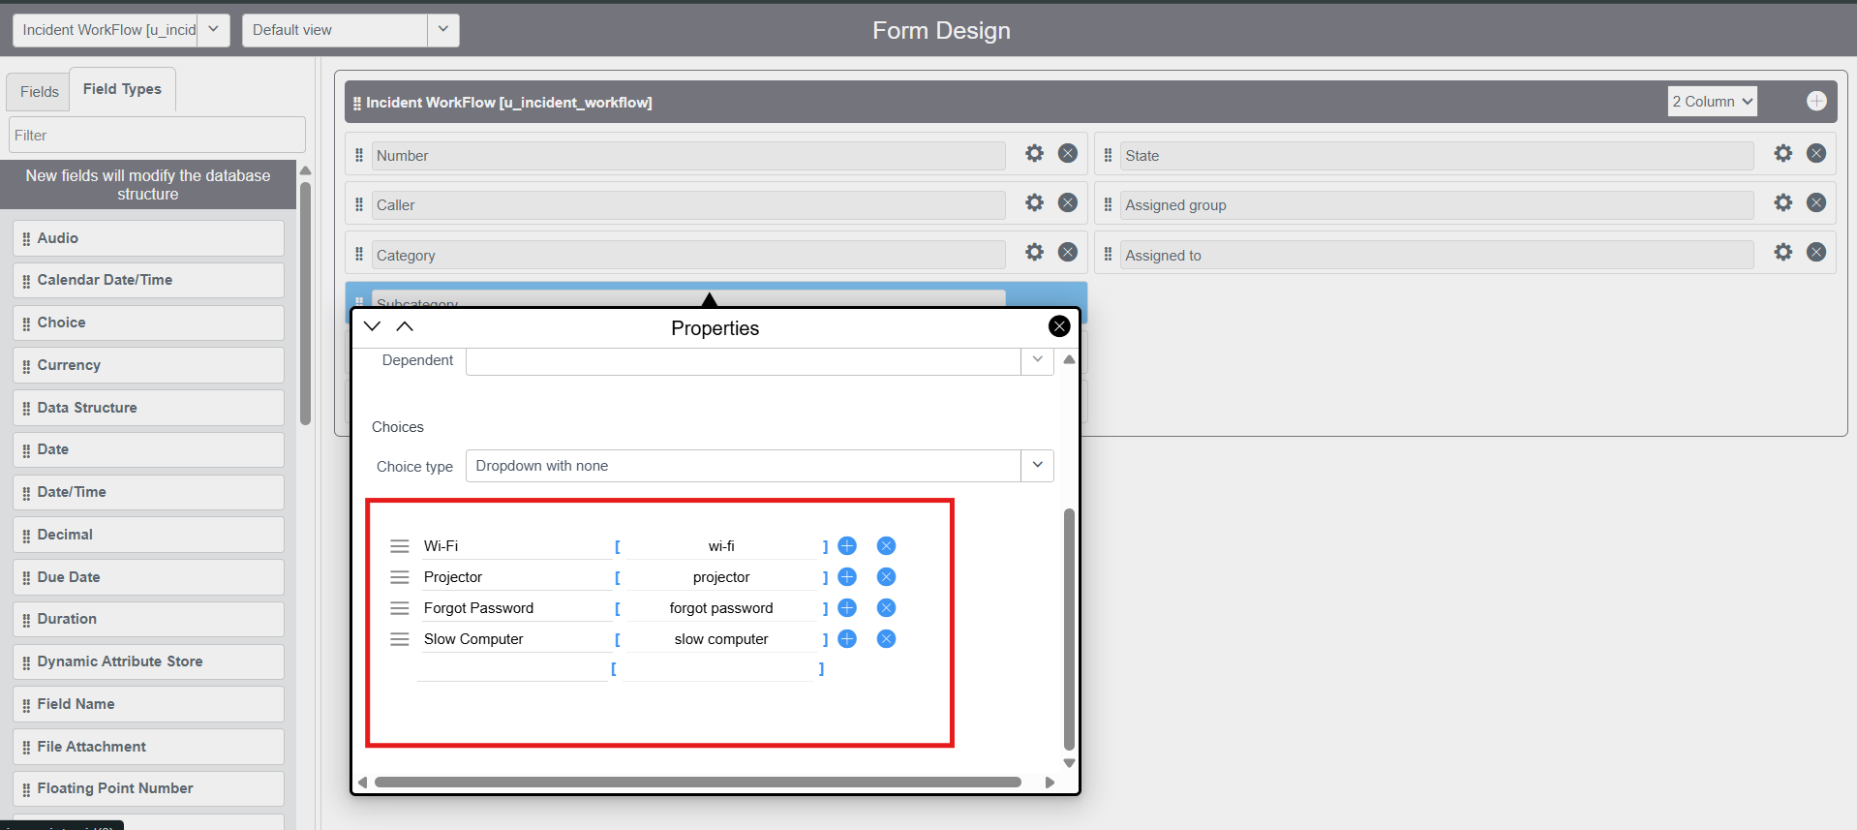
Figure 6.8: Form Designer Field Choice Configuration for Subcategory [Wi-Fi, Projector, Forgot Password, Slow Compter]
6. Configuring Dependent Choices on Subcategory
Navigation: Right click 'Subcategory' field -> Configure Dictionary -> Advanced view -> Dependent Field section -> Check 'Use dependent field = true', Dependent on field: 'category'. In Choices related list, map: Wi-Fi -> network, Projector -> hardware, Forgot password -> access, Slow computer -> performance.
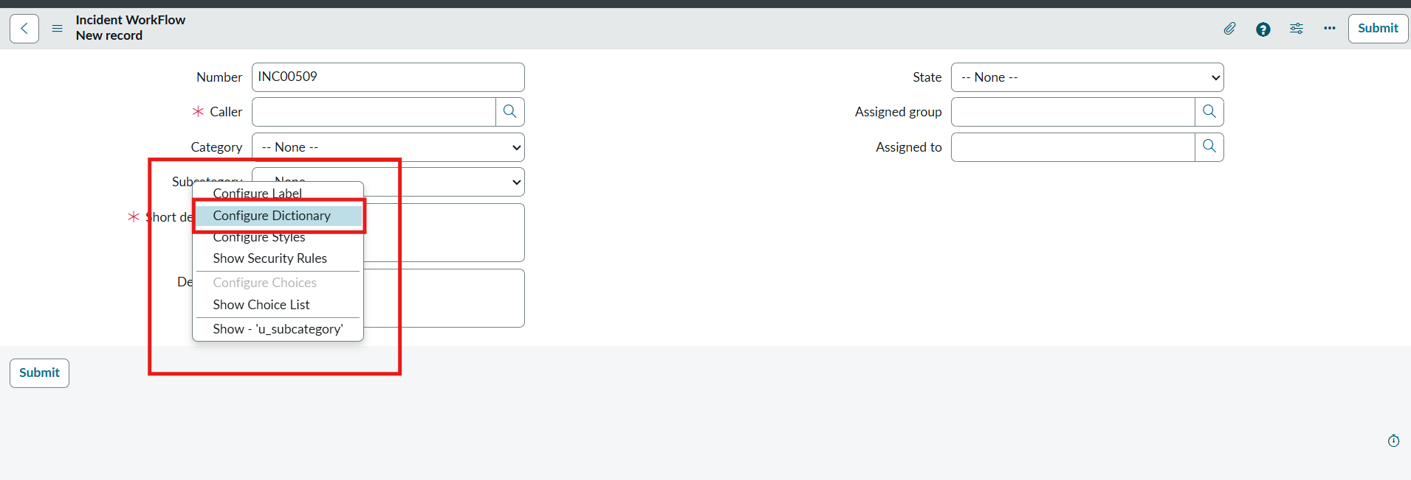
Figure 6.9: Subcategory Dictionary Entry -> Dependent Field Configuration (Dependent on: category)
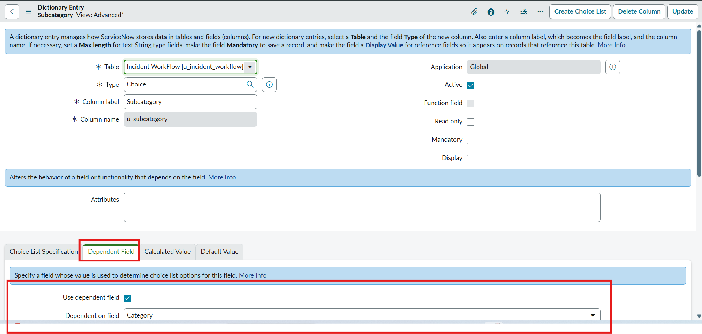
Figure 6.10: Mapping Subcategory Choices to Dependent Category Values in System Dictionary
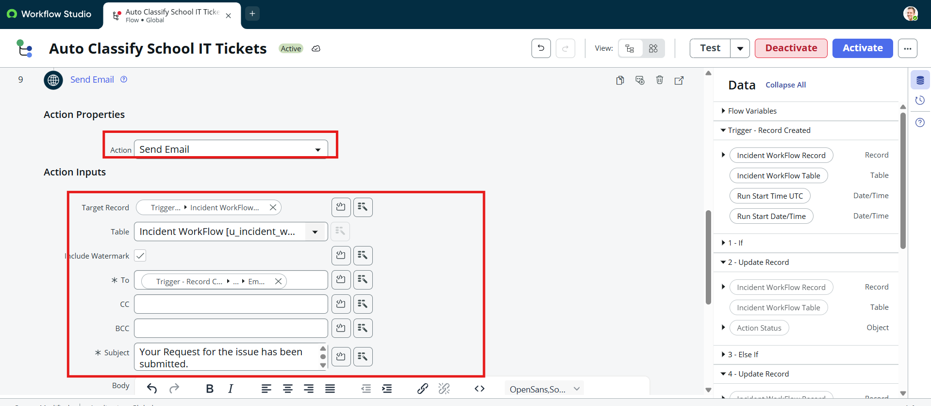
Figure 6.11: Verification: Selecting Category 'Hardware' dynamically reveals Subcategory 'Projector'
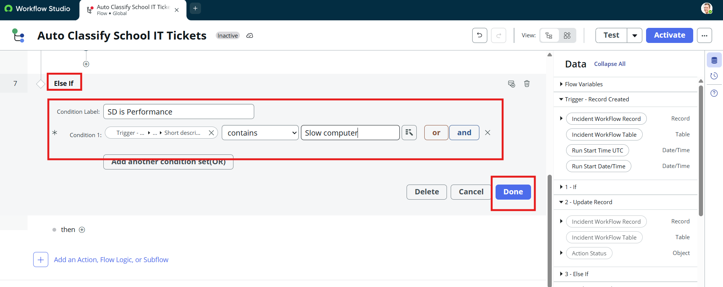
Figure 6.12: Verification: Selecting Category 'Access' dynamically reveals Subcategory 'Forgot Password'
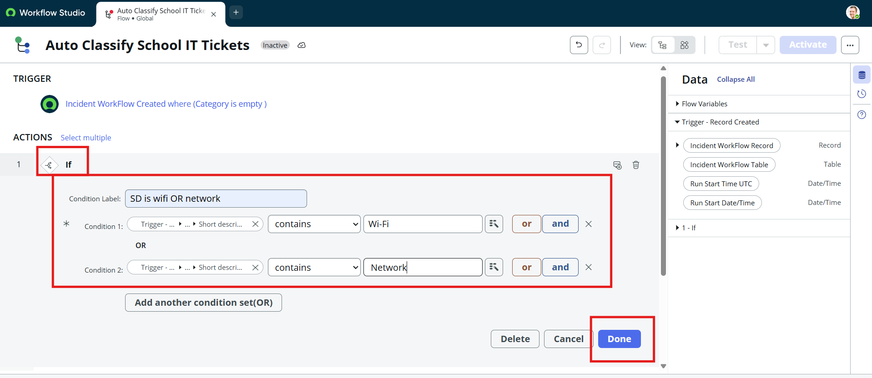
Figure 6.13: Verification: Selecting Category 'Performance' dynamically reveals Subcategory 'Slow Computer'
7. Flow Designer Automation & Notification Setup
Navigation: All menus -> Process Automation -> Flow Designer -> New -> Flow. Name: 'Auto Classify School IT Tickets', Application: 'Global'.
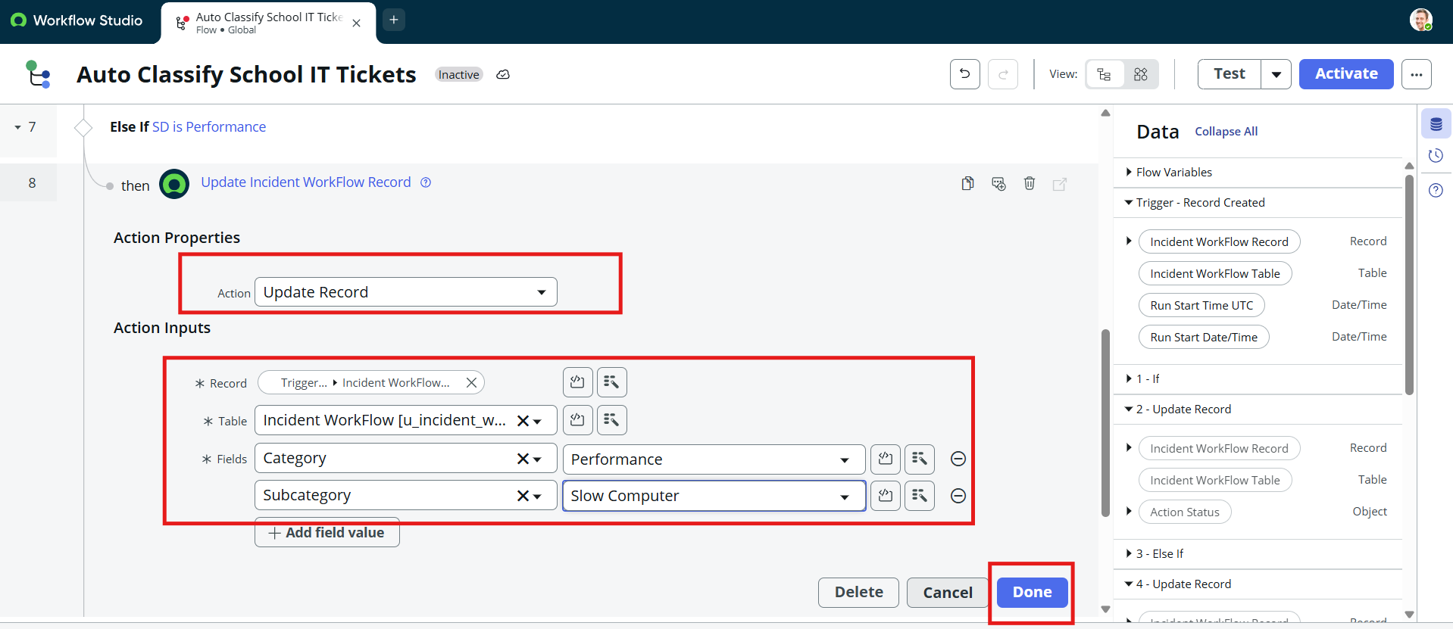
Figure 6.14: Accessing Flow Designer under Process Automation and Workflow Studio
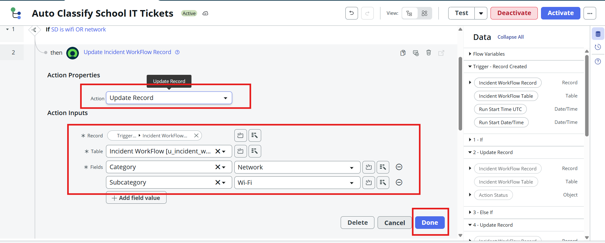
Figure 6.15: Creating Flow 'Auto Classify School IT Tickets' in Global Application Scope
Trigger & Decision Logic Configuration:
Trigger: Record Created on Table 'Incident Workflow (u_incident_workflow)' where 'Category is empty'.
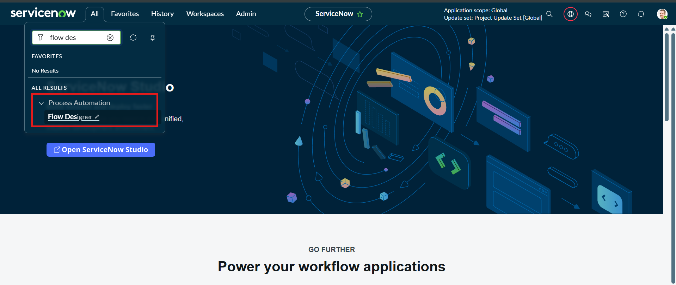
Figure 6.16: Flow Trigger Configuration (Record Created, Category is empty)
Branch 1 (Wi-Fi): If Short description CONTAINS 'Wi-Fi' OR CONTAINS 'Network' -> Action: Update Record -> Category = Network, Subcategory = Wi-Fi.
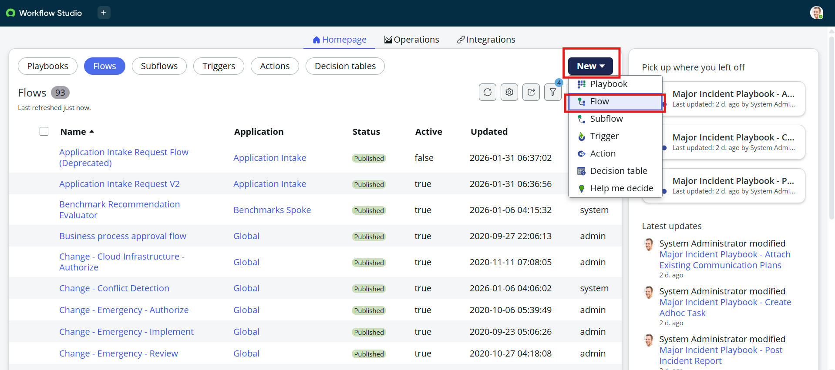
Figure 6.17: Branch 1 Logic: If Condition (Short Description contains Wi-Fi OR Network)
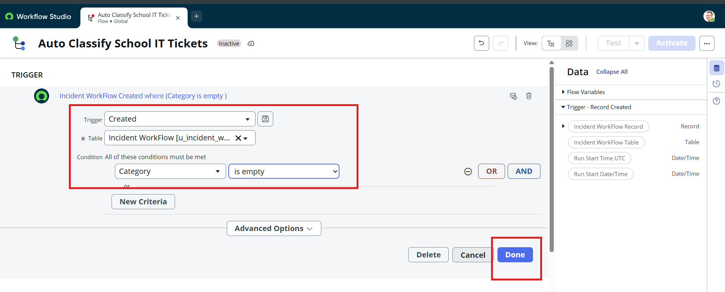
Figure 6.18: Branch 1 Action: Update Record (Category = Network, Subcategory = Wi-Fi)
Branch 2 (Projector): Else If Short description CONTAINS 'Projector' -> Action: Update Record -> Category = Hardware, Subcategory = Projector.
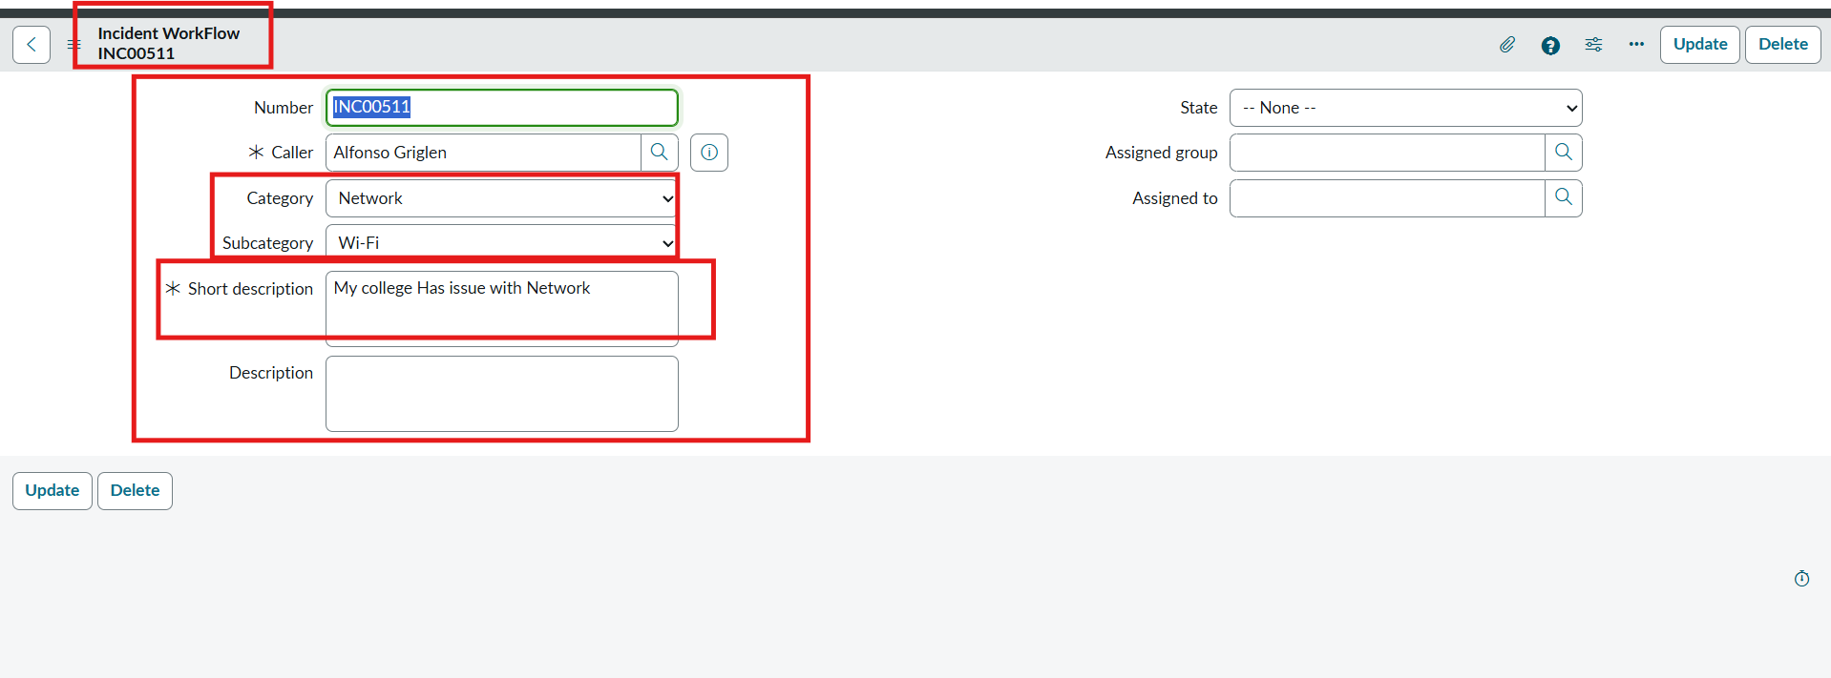
Figure 6.19: Branch 2 Logic: Else If Condition (Short Description contains Projector)
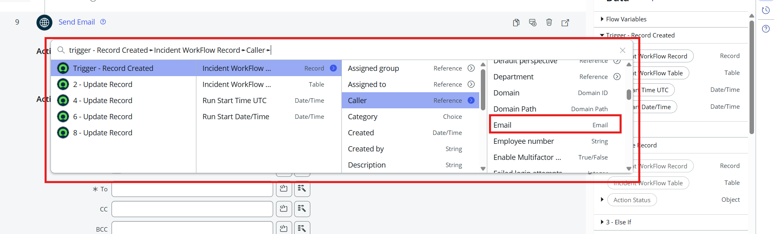
Figure 6.20: Branch 2 Action: Update Record (Category = Hardware, Subcategory = Projector)
Branch 3 (Password): Else If Short description CONTAINS 'Forgot password' -> Action: Update Record -> Category = Access, Subcategory = Forgot Password.
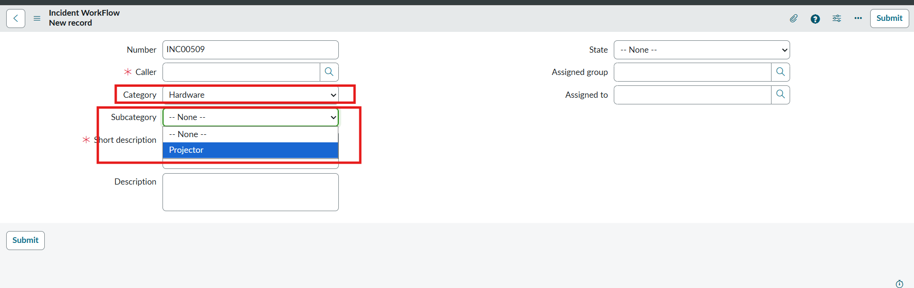
Figure 6.21: Branch 3 Logic: Else If Condition (Short Description contains Forgot password)
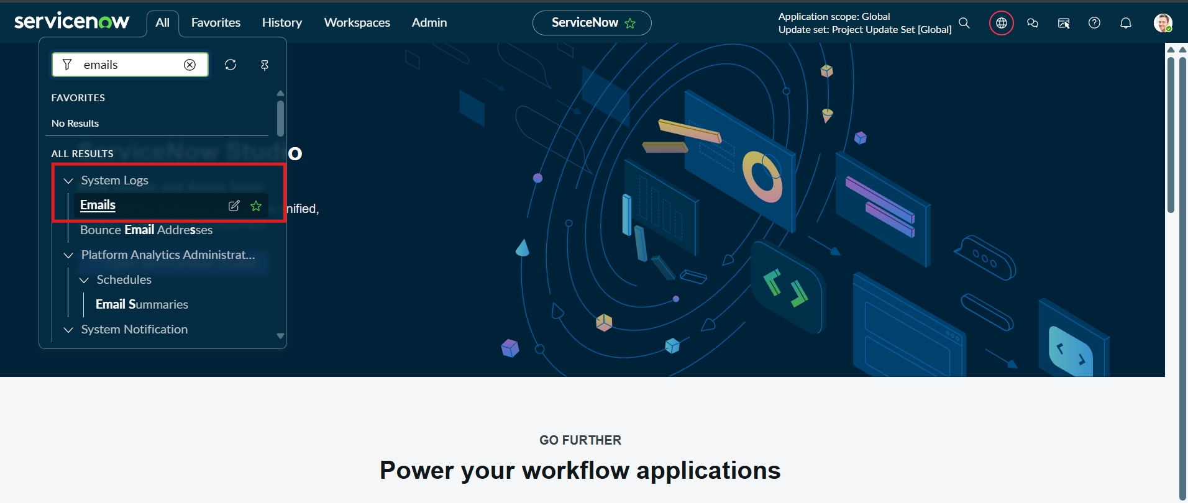
Figure 6.22: Branch 3 Action: Update Record (Category = Access, Subcategory = Forgot Password)
Branch 4 (Slow Computer): Else If Short description CONTAINS 'Slow Computer' -> Action: Update Record -> Category = Performance, Subcategory = Slow computer.
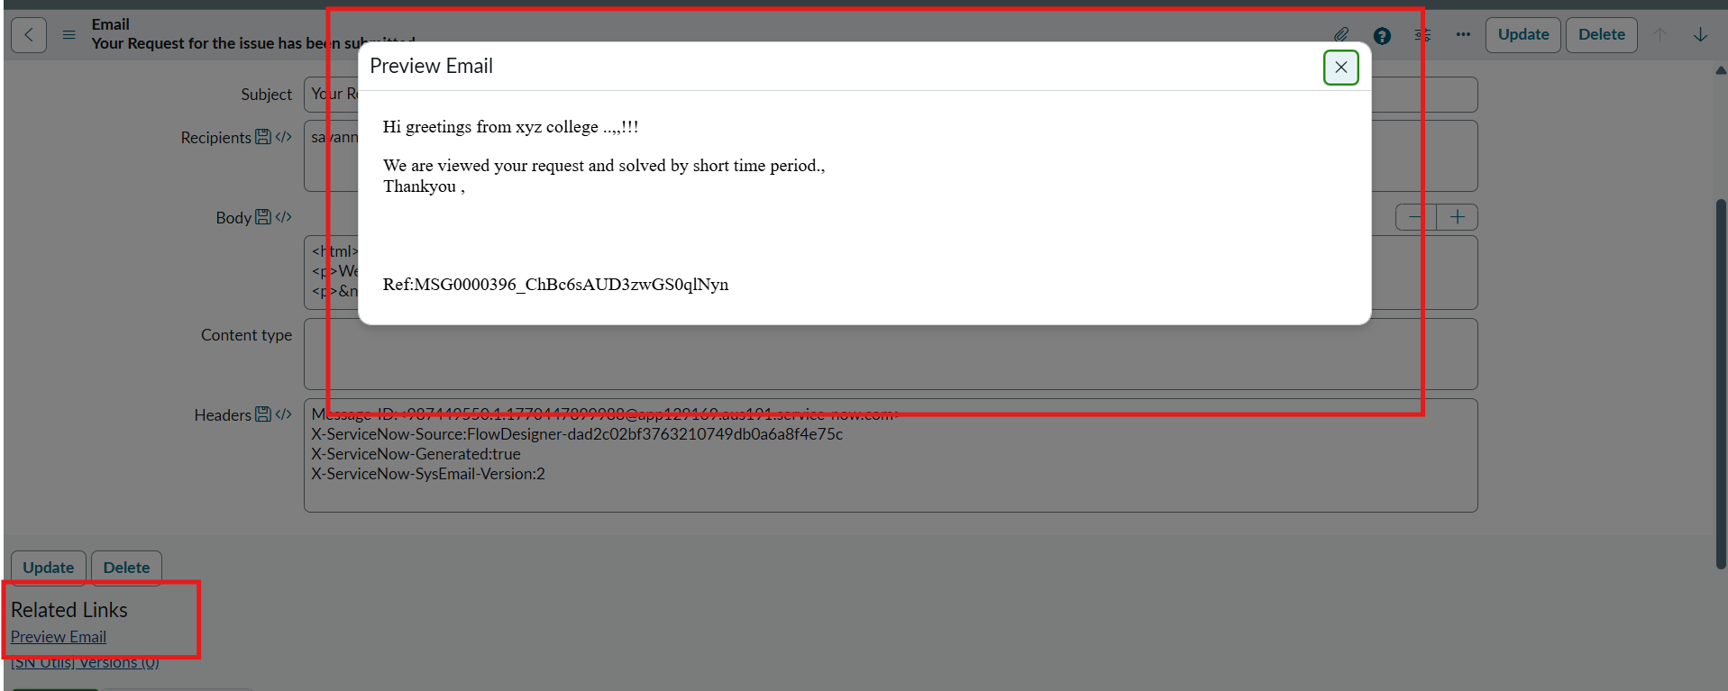
Figure 6.23: Branch 4 Logic: Else If Condition (Short Description contains Slow Computer)
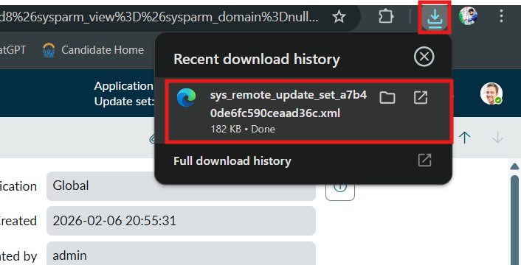
Figure 6.24: Branch 4 Action: Update Record (Category = Performance, Subcategory = Slow Computer)
Action 5: Automated Caller Email Notification
Action: Send Email. In 'To' field, use Data Pill picker: Trigger -> Incident Workflow Record -> Caller -> Email. Subject: 'Your Request for the issue has been submitted.' Body: Confirmation greeting. Click Activate on top right.
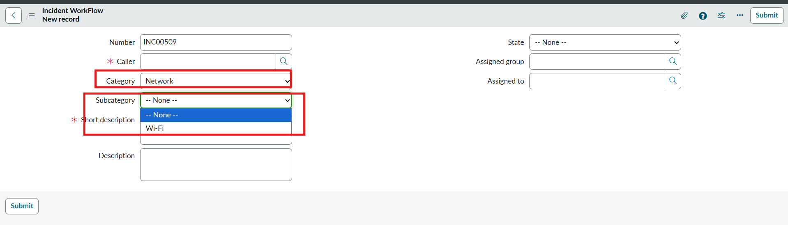
Figure 6.25: Configuring 'Send Email' Action with Data Pill Binding (Caller -> Email)
8. Testing & Validation Execution Evidence
Test Scenario 1 (Wi-Fi): Caller 'Alfonso Griglen', Short Description 'WiFi not working in library'. Record saves and auto-populates INC00511 with Category = Network, Subcategory = Wi-Fi.
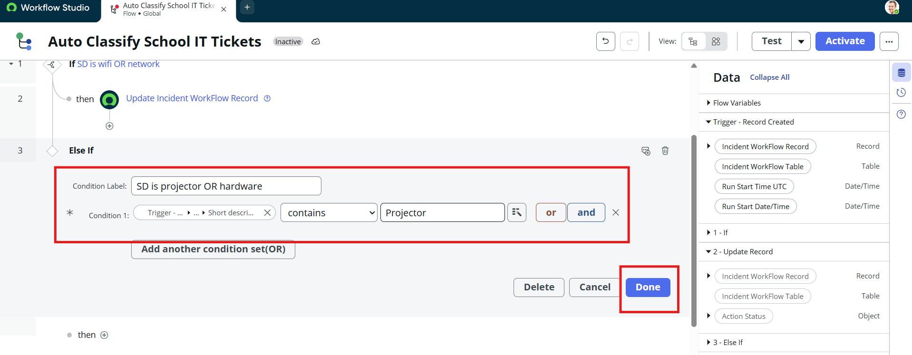
Figure 6.26: Test Scenario 1 Verification: Record INC00511 Auto-Classified as Network / Wi-Fi
System Logs Email Inspection: Navigate to System Logs -> Emails, search subject 'Your Request for the issue has been submitted', click Preview Mail.
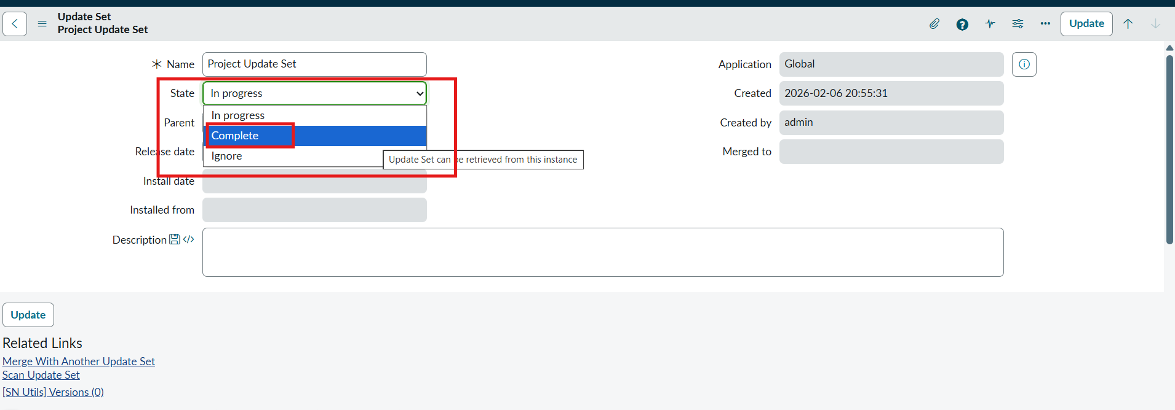
Figure 6.27: Navigating to System Logs -> Emails to verify outbound notification dispatch
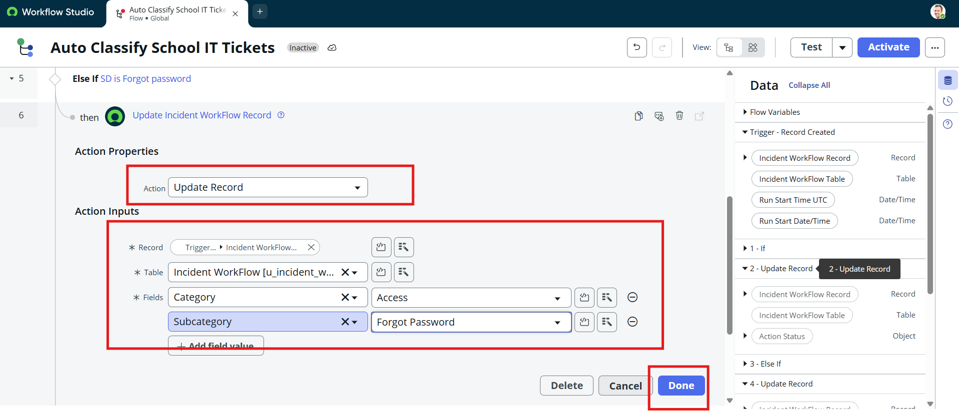
Figure 6.28: System Logs Emails table showing outbound message to savannah.kesich@example.com
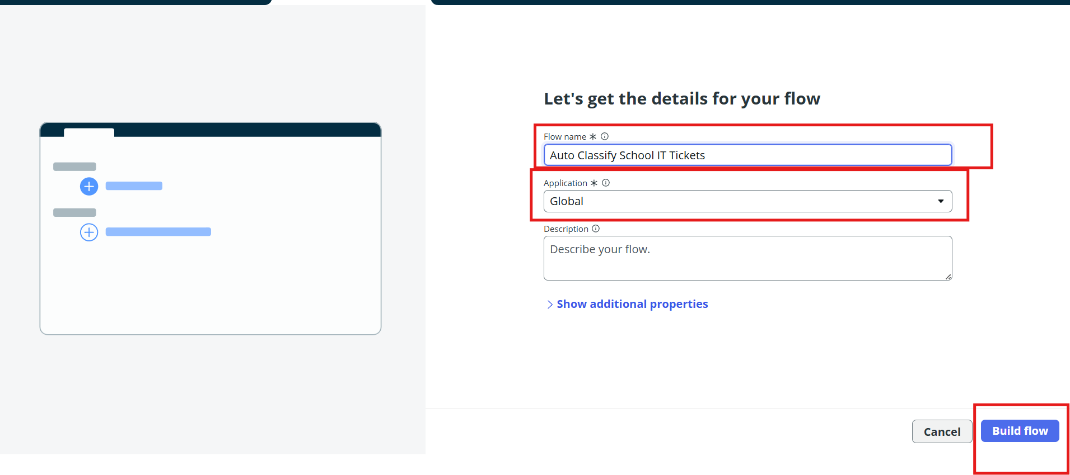
Figure 6.29: Preview Email Dialog showing personalized confirmation message to caller
Test Scenario 2 (Projector): Caller 'Sam Sorokin', Short Description 'Projector not turning on'. Record saves and auto-populates INC00512 with Category = Hardware, Subcategory = Projector.
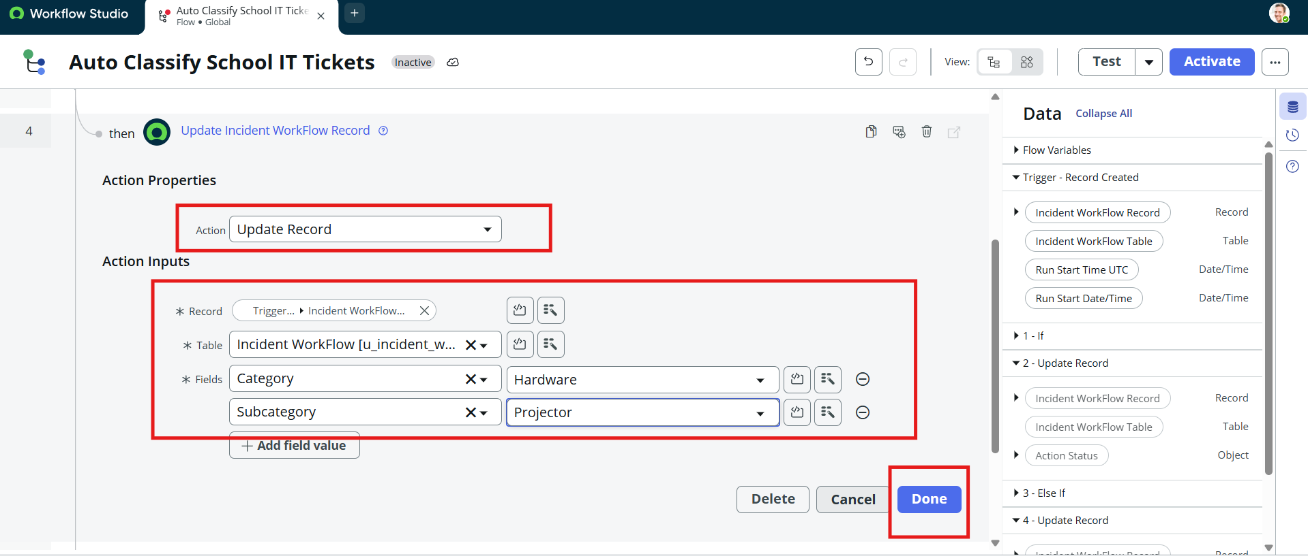
Figure 6.30: Test Scenario 2 Verification: Record INC00512 Auto-Classified as Hardware / Projector
9. Deployment & Update Set XML Export
Navigation: All menus -> System Update Sets -> Local Update Sets -> Open 'Project Update Set' -> Change State to 'Complete' -> Save form -> Click 'Export to XML'.
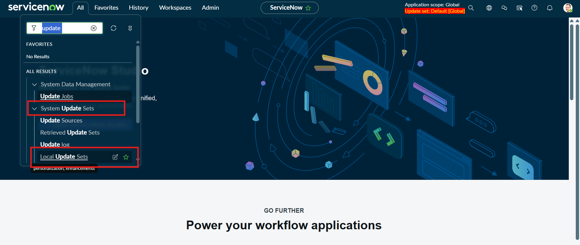
Figure 6.31: Marking Project Update Set as 'Complete' and clicking 'Export to XML'
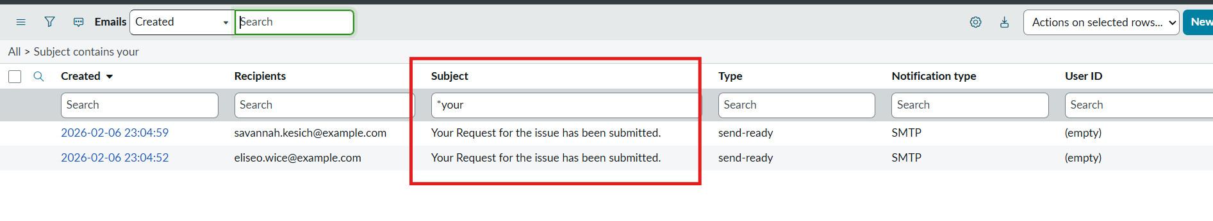
Figure 6.32: Browser Download History showing exported sys_remote_update_set_a7b40de6fc590ceaad36c.xml (182 KB)
10. Conclusion
The Auto Ticket Classification using Flow Designer project successfully delivers a complete, end-to-end automation solution for a school IT helpdesk. The primary objective of reducing manual effort in ticket categorization and improving response efficiency has been fully achieved.

